**S313F Group Project**

**Application Name： Fitness Tracks**

| Student Name | Student ID |
| --- | --- |
| CHEN Zhipeng | S12991642 |
| Chen XuChu | S12824956 |
| YI Yicheng | S13020860 |

# Aim

The aim of this project is to design, develop, and evaluate a mobile application that displays information about fitness walking tracks in Hong Kong. The application will allow users to request information about fitness walking tracks and provide them with a comprehensive list of options. The primary goal of the application is to promote healthy lifestyles and encourage physical activity. The application will include distinct features such as a map of walking tracks, information about the distance and difficulty of each track, and GPS location reviews and other information.

# App function

The whole application will provide the following functions:

1. display all related information about fitness trails in kong kong
2. Provide Google Location Services
3. Provide search function
4. three Language translation function
5. reset operation function

video demonstration on youtube：

<https://youtu.be/awEF0BucsLw>

# Requirements Analysis and Design

* Collect data about fitness trails, and json of stored in GitHub

<https://raw.githubusercontent.com/Professionalthingsarecrap/Fitness-walking-tracks/main/facility-fw.json>

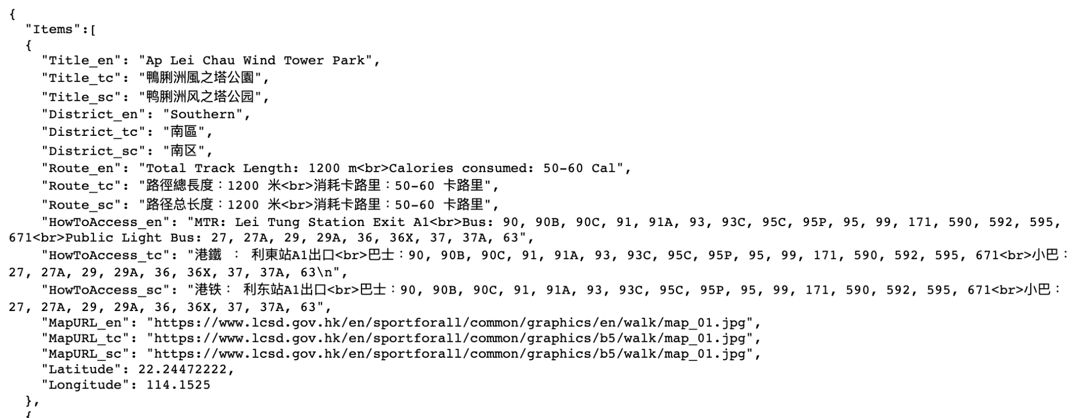

* Display all relevant information of fitness tracks in kong kong, such as fitness tracks name, location, total track length, calories consumed， how to access and so on.

|  |  |
| --- | --- |

* Prodive Google Location Services, Help you get a more accurate location.

|  |
| --- |

* Provide a search function, users can search for specific information

|  |
| --- |

* Language translation function, providing three languages Simplified Chinese, Traditional Chinese, English

|  |  |
| --- | --- |
|  |  |

* reset function, restore all operations to the original settings

|  |
| --- |

# 